**Network Architecture 1**

**Project Phase 1-Part2**

**Name: Apuroop Reddy Tummala Id:16296513**

**Part II. Group Chatting Program (50%) (Due 04/09)**

Develop a simple chat program (similar to google hangout and skype chat),and show the

screenshots of the execution of the below.

Extend the first program to chat client-server program following these steps.

a) (5%) A chat server will accept a single client connection and display everything the client

types. If the client user types ‘exit’, both client and server will end the program.

1. **Server & Client Output(side by side)**

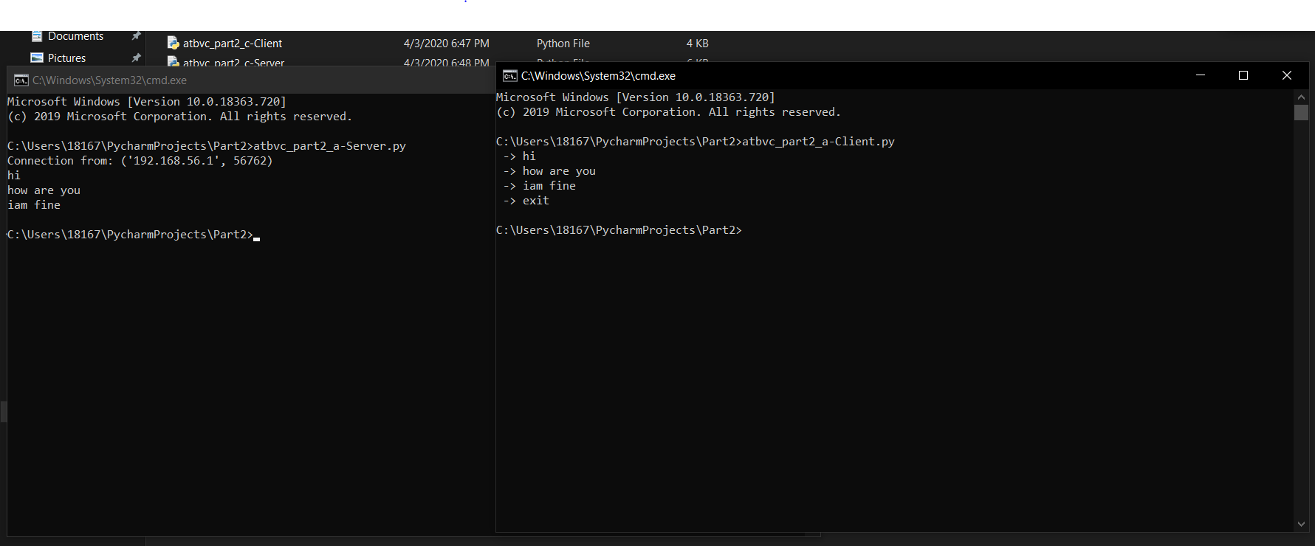

b) (5%) A server now remains ‘open’ for additional connection once a client quits. The

server can handle at most one connection at a time.

c) (10%) A server now can handle multiple clients at the same time. The output from all

the connected clients will appear on the server’s screen.

1. **Server Output**-

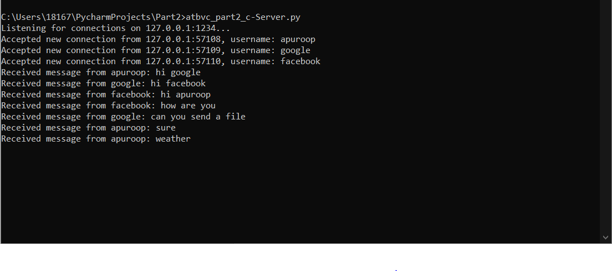

1. **Client 1 – Output**

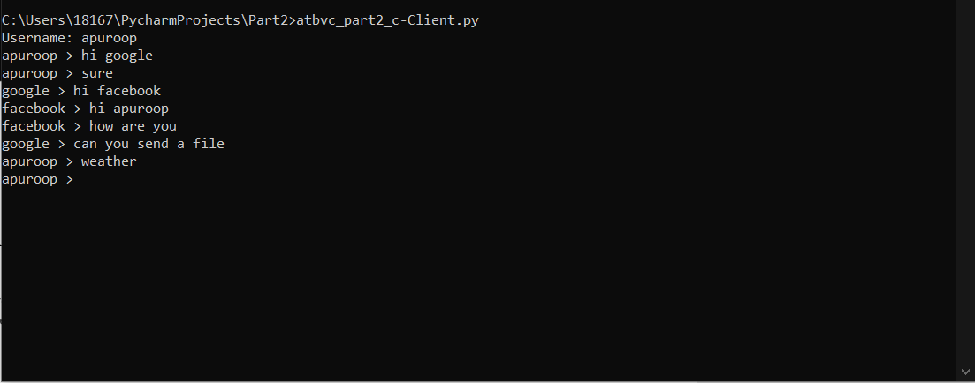

1. **Client 2 – Output**

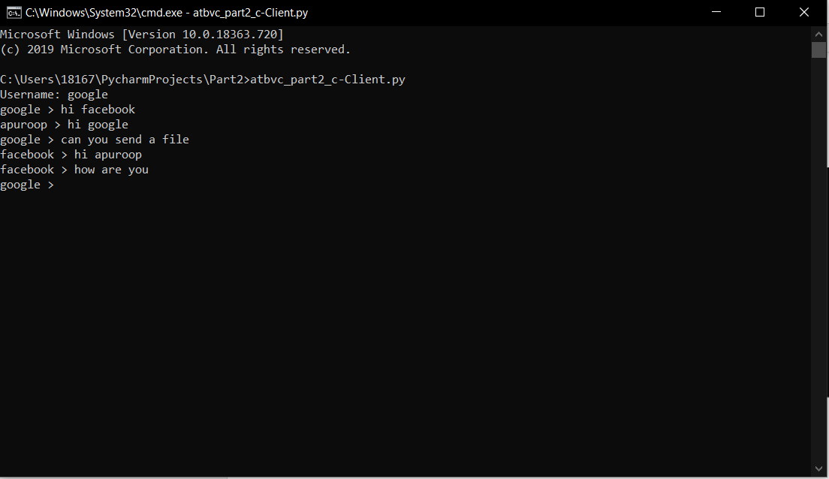

1. **Client 3 – Output**

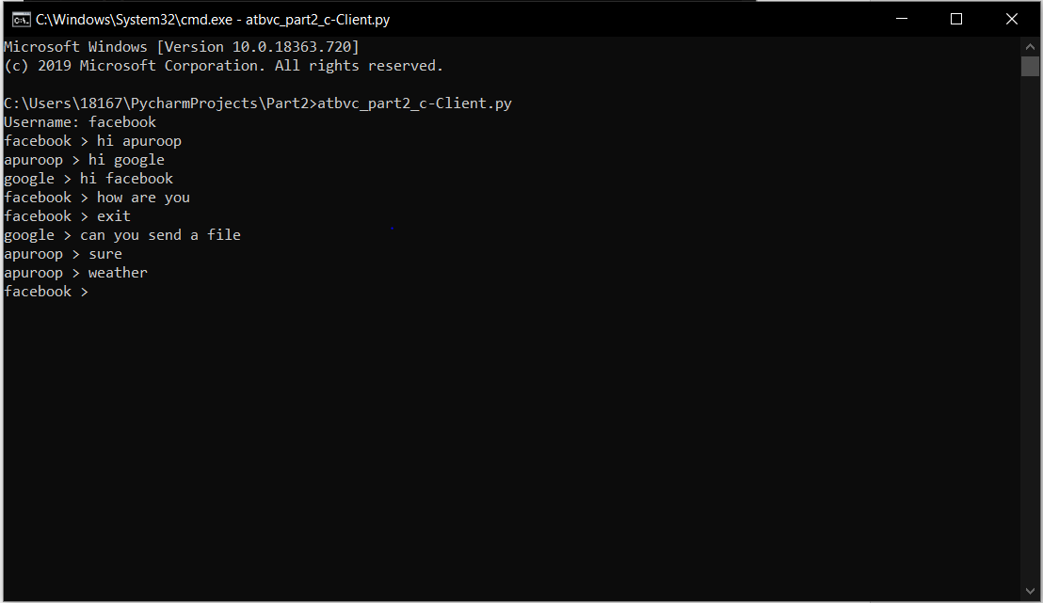

d) (30%) A server replies next 3 days temperature of Kansas city ( eg 30 C/45 F), when client sends

“Weather” otherwise server echoes same message.

**d) Server Output**-

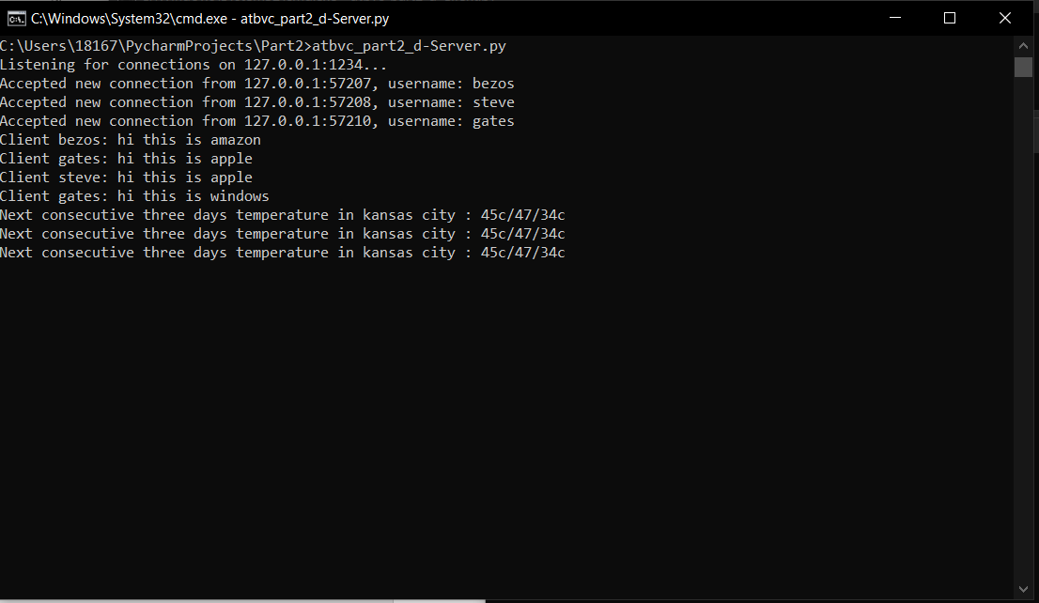

**d) Client 1 Output**-

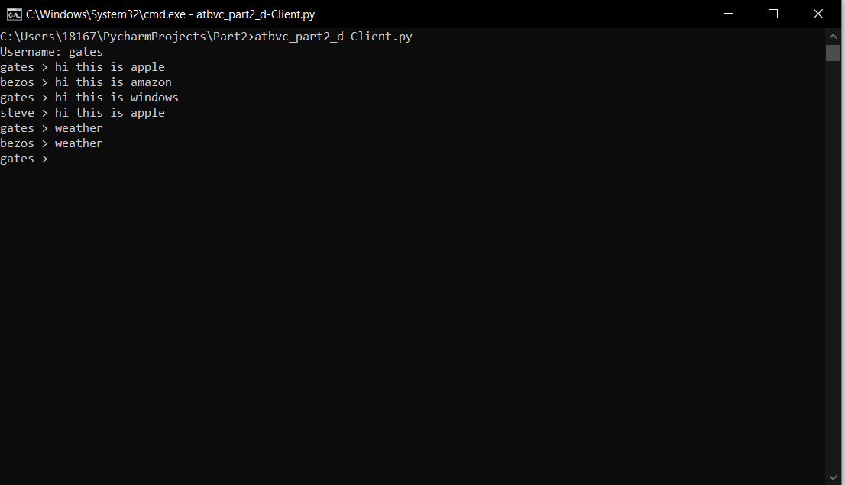

**d) Client 2 Output**-

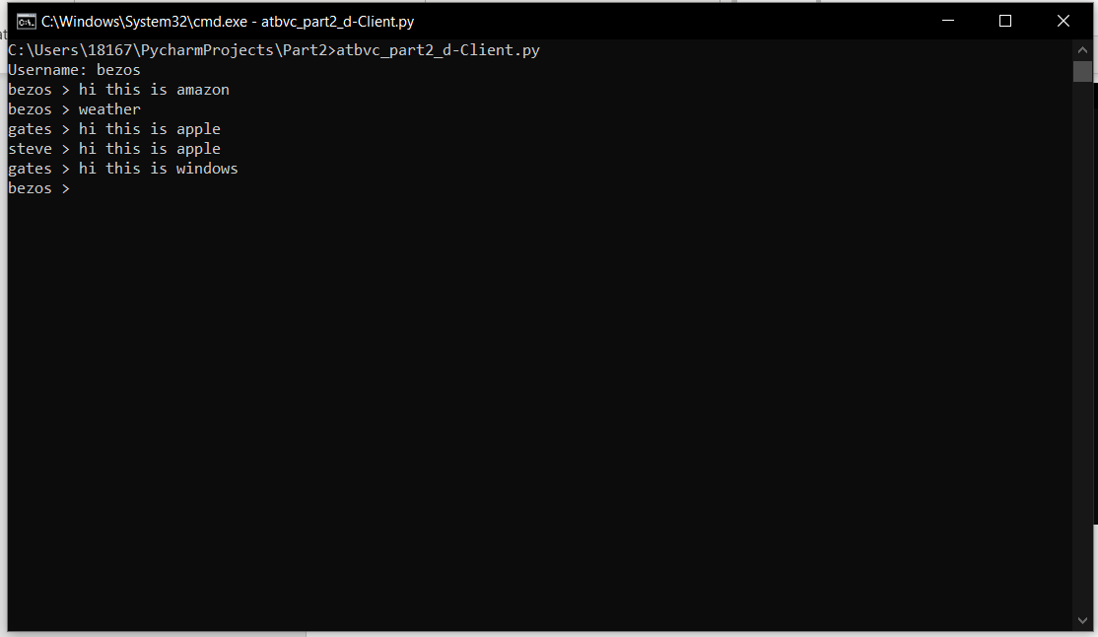

**d) Client 3 Output**-

